**Name:b.Sai Hithesh**

**USN: 1BM17CS021**

**Program Number :**

**Program Title : Gas sensor**

**AIM: LED glows whenever gas in detected.**

**Hardware Required:**

* **Arduino Board**
* **LED**
* **Gas sensor**
* **Breadboard**

**Circuit Diagram:**

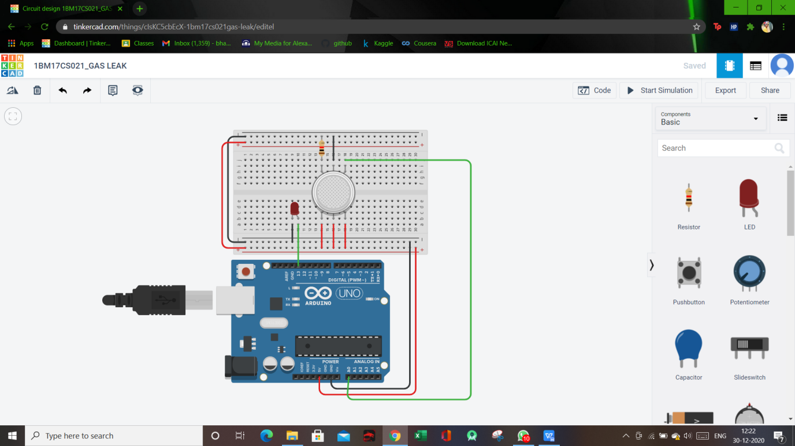

**Circuit diagram along with code:**

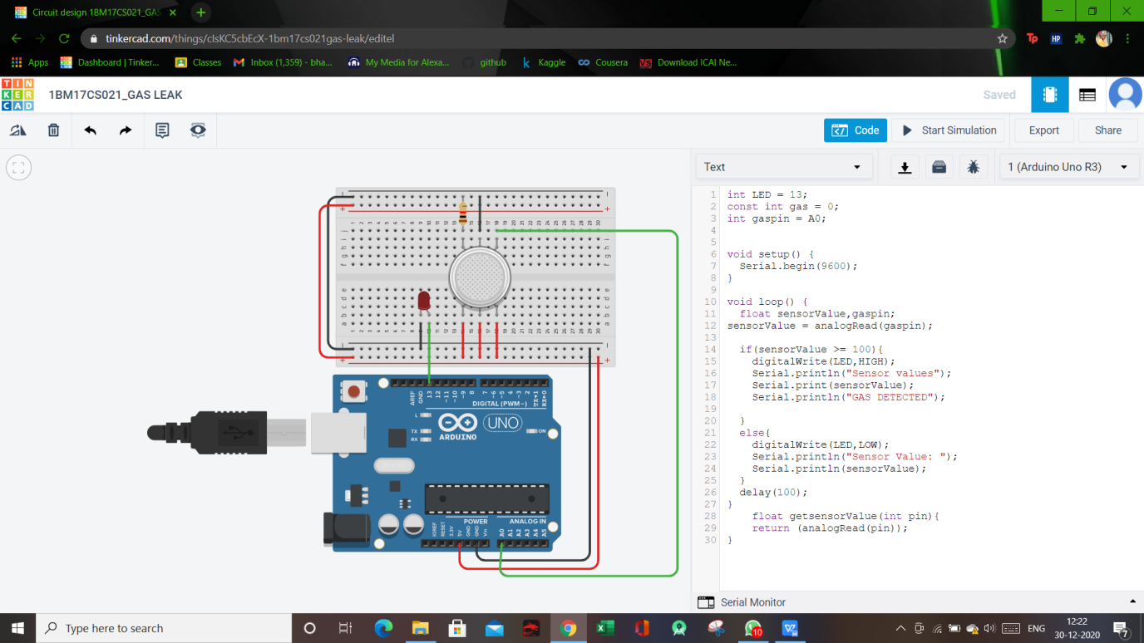

**Simulation:**

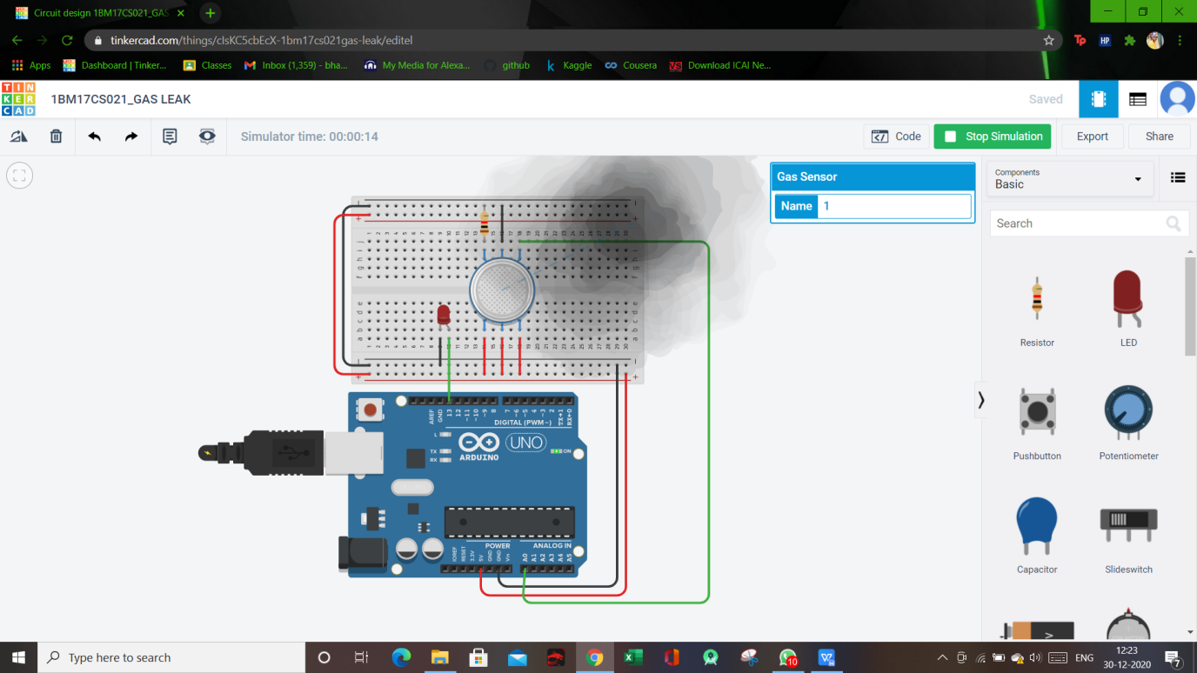

**Code:**

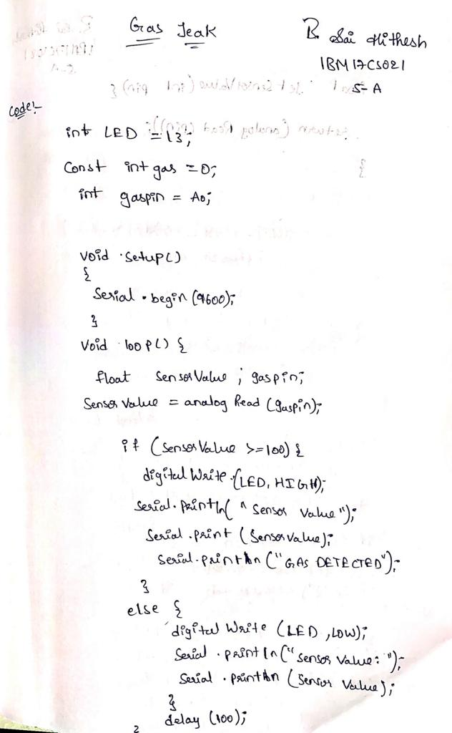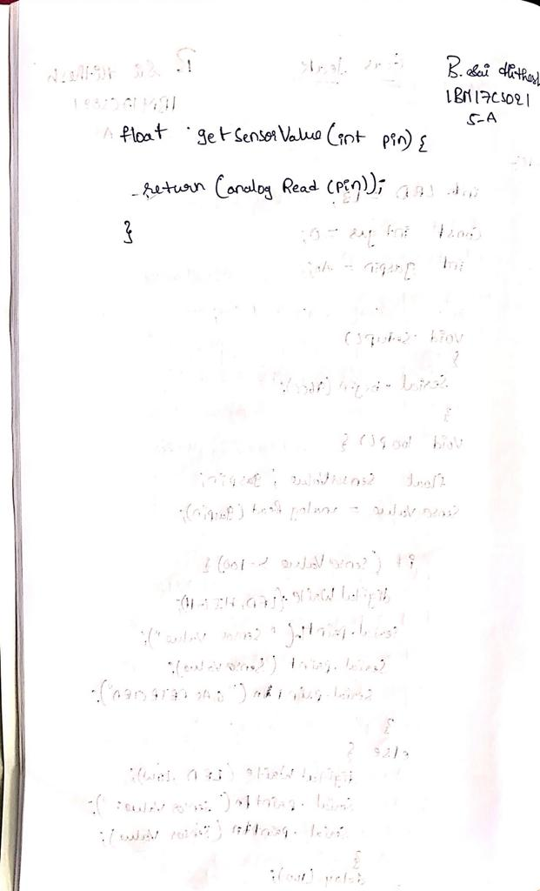

**Observation/output:**

LED glows whenever gas is observed.